**Soft Computing – Fuzzy Logic**

*Anjaneya Tripathi (106118010), Harshit Agarwal (106118036) – 3rd Year*

**What is a fuzzy inference system?**

Fuzzy inference is a method that interprets the values in the input vector and, based on some sets of rules, assigns values to the output vector. It is the process of formulating the mapping from a given input to an output using fuzzy logic. The mapping then provides a basis from which decisions can be made or patterns discerned. The process of fuzzy inference involves all of the pieces described so far, i.e., membership functions, fuzzy logic operators, and if-then rules.

**Mamdani Fuzzy Inference System**

Mamdani fuzzy inference was first introduced as a method to create a control system by synthesizing a set of linguistic control rules obtained from experienced human operators. In a Mamdani system, the output of each rule is a fuzzy set which are more intuitive and easier to understand.

Mamdani-type inference expects the output membership functions to be fuzzy sets. After the aggregation process, there is a fuzzy set for each output variable, which needs defuzzification.

**Solving the Braking Problem:**

We are required to design a Mamdani fuzzy logic controller (FLC) for a car braking system. We consider three input parameters – x, y and z that affect whether a driver should press the brake or not and using appropriate membership functions, determine the relative magnitude of brake that should be applied by the driver.

**Input Parameters:**

The input parameters chosen are – visibilty, speed of vehicle based on the traffic signals and obstructions in the path of the automobile. The reason these parameters were chosen is because it was felt that these factors affect the driver’s decision to brake most significantly.

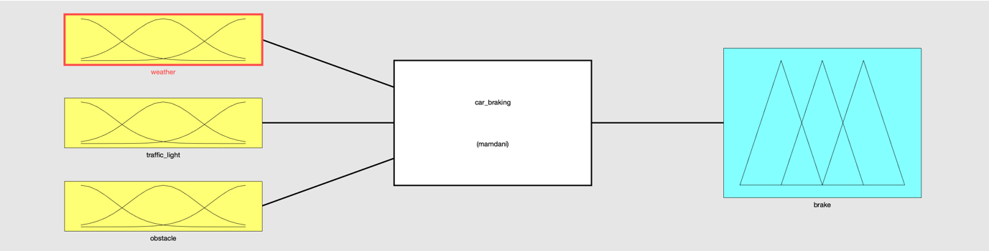

**Membership Functions:**

Membership functions provide us with a graphical representation of a fuzzy set. The x-axis represents the universe of discourse, while the y-axis represents the degrees of membership. There are multiple membership functions available such as triangular(trimf), trapezoidal(trapmf), gaussian(gaussmf) etc. We can also define a custom membership function. The membership functions used are as below:

Visibility (based on weather):

The input parameter ‘visibilty’ has a triangular membership function. It’s value ranges from 0 to 1. It is defined as:

Sunny [-0.417 -1.319e-17 0.306], Rainy[0.164 0.5 0.769] and Hazy[0.583 1 1.416]

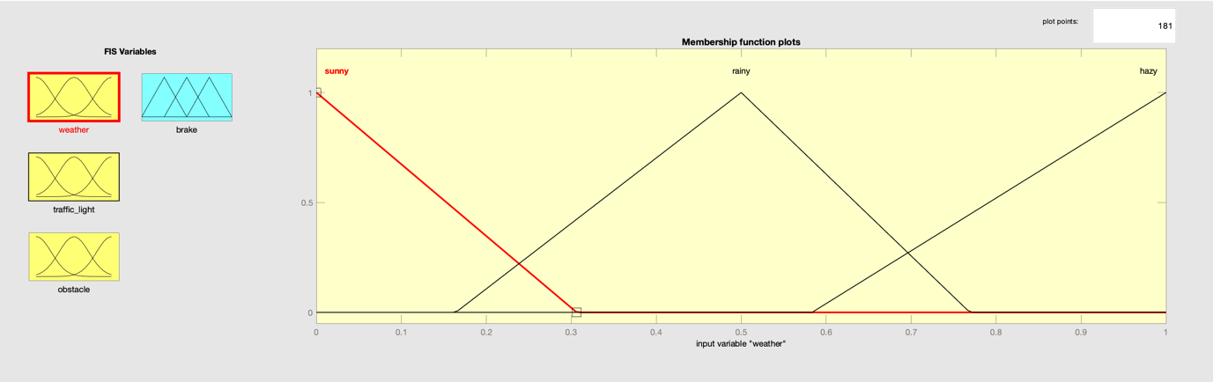

Speed of the Vehicle (based on traffic lights):

The input parameter ‘speed’ is represented by a gaussian membership function with a range of 0 to 1. It is defined as:

Green[0.2878 0], Yellow[0.109 0.5] and Red[0.1649 1]

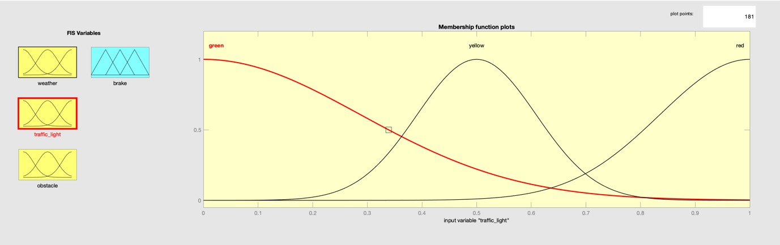

Obstructions in the Path:

The input parameter ‘obstruction’ has a trapezoidal membership function with a range of 0 to 1. It is defined as:

Absent [-0.9 -0.1 0.555 0.67125] and Present[0.532 0.9 1.1 1.4]

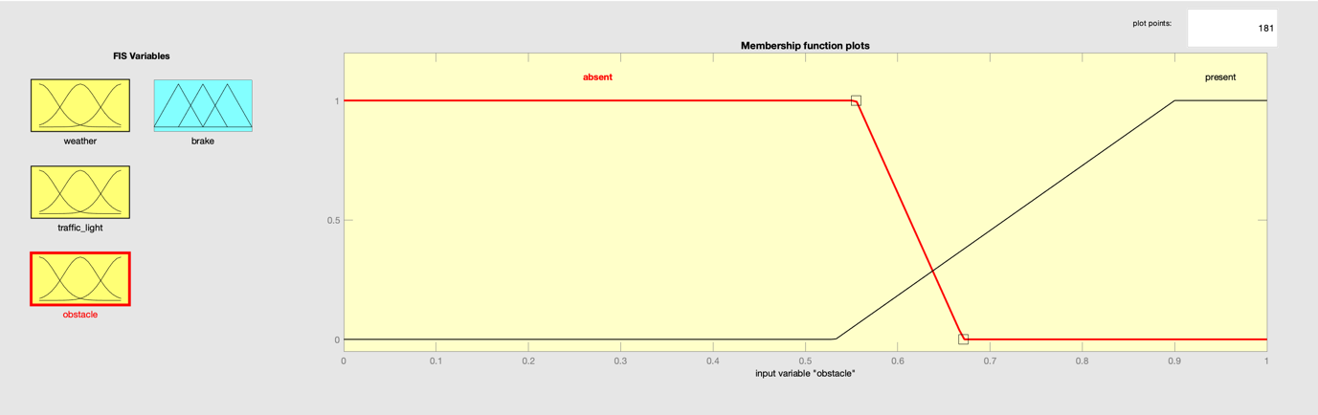

Pressure (applied by the foot on the brake):

The output parameter is ‘pressure’, and is represented by a triangular membership function with range 0-1. It denotes the amount of brake to be applied by the driver. It is defined as:

Low[-0.416 0 0.416], moderate [0.083 0.5 0.916] and high[0.583 1 1.416]

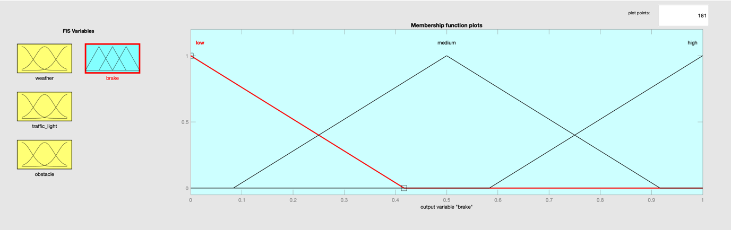

**Rules and Output:**

The Mamdani fuzy logic system has rules which will be used to evaluate the parameters and give a suitable output in accordance with the inputs.

We can define the rules as follows:

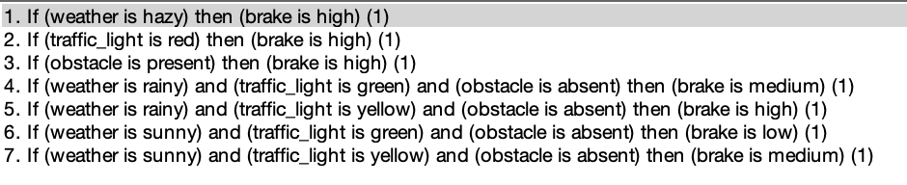

These rules are present in the verbose format for better interpretation. These rules work with the fuzzy sets and a fuzzy result is obtained.

However, the final result expected is a crisp one, therefore we need to use defuzzification techniques and arrive at crisp results.

